Warning – Perimeter Alarm – CGEA1.3

Functional Description

The purpose of the Perimeter Alarm Warning feature is to alert the driver of impending perimeter alarm activation.

At the vehicle level, assuming the perimeter alarm is armed, when the driver's door is opened after unlocking via a key in the door cylinder, a delay timer should start (12 seconds) and the Perimeter Alarm Warning (chime and text display) shall initiate. If the vehicle is not disarmed prior to the 12 second timer expiring, the actual perimeter alarm is triggered. The methods to reset the delay timer and disarm the perimeter alarm system include:
- Valid PATS key is turned to RUN/START in the ignition
- Remote Control Unlock Command
- Keyless Entry Keypad Unlock Command

This chime shall stop sounding and the display shall become inactive immediately upon disarming the perimeter alarm system.

The Perimeter Alarm warning display shall be synchronized and (de)activated concurrent with the warning chime.

This warning is displayed on the Message Center display whenever the Perimeter_Alarm_Chime_Status_Flag = TRUE. The Perimeter_Alarm_Chime_Status_Flag status flag is defined in the Perimeter Alarm Warning Chime section of this SPSS.

Interface

Interface Context Diagram (I/O Block Diagram)
Figure 1.1 Warning –Perimeter Alarm Context Diagram

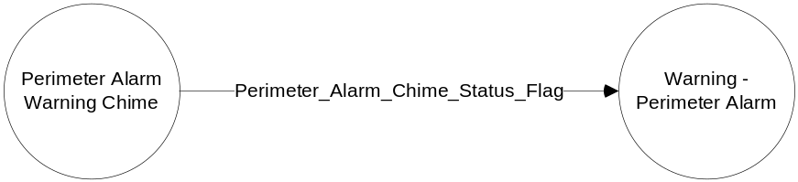

Inputs

- Perimeter_Alarm_Chime_Status_Flag
See the Perimeter Alarm Warning Chime section of this SPSS for definition of the state of this flag.

Outputs
- Warning Message W650.
For definition of W650, see the Text Message List - X Display Y x Z section of this SPSS (where X, Y, and Z are appropriate values in this document).

Function/Performance

Operational Description

- Warning Message W650 shall be Active whenever Perimeter_Alarm_Chime_Status_Flag = True, and shall be Inactive whenever Perimeter_Alarm_Chime_Status_Flag ≠ True.

- This warning is capable of being active in LIMITED and NORMAL modes. However, this warning is usually only active in LIMITED mode, and thus does not appear under SYSTEM CHECK.

- This warning is not a local sleep inhibitor. It is synchronized with the Perimeter Alarm chime, which is a local sleep inhibitor. However, the chime is of a finite duration (12s), and the warning shall become inactive when the chime has expired.

- For definition of how the Message Center arbitrates and displays Active warnings, see the Warning / Alert Display Logic Diagram, located in the Message Center – X Display with W Button Interface section of this SPSS (where X and W are appropriate values in this document).

SPSS Module Revision History

Revision Level | Name | Change Description | Date
1.0 | V. Patel | No updates needed for CGEA1.3. Based on CGEA Warning - Perimeter Alarm STSS V1.0 | 05/11/2010

